Software Architecture Design Specification
FOR
Volunteer Management System
(VMS)

CLIENT
PROJECT | Volunteer Management System (VMS)
TITLE | Software Architecture Design Specification
VERSION | 0.2a0.1a
DATE | 28-Feb-2011
 | ORIGINATOR
 | Name / Signature | Team 8S
 | APPROVAL
 | Name / Signature | Phung Kim Cuong, Dio
Institute of Systems Science |  | Document Reference
25 Heng Mui Keng Terrence  Singapore 119615 |  | VMS/PM-1.5.1/1

 | Acceptance
 | Customer Signature |  | Customer Signature
 | Name & Designation |  | Name & Designation
 | Date & Company Stamp |  | Date & Company Stamp

Revision History

Date | Version | Description | Author
28-Feb-2011 | 0.1 | Creation | Team 8S
02-Aug-2011 | 0.2a | Updates | Team 8S

Table of Contents

1. Document Overview 4
1.1 Target Audience 4
2. High Level Application Architecture 5
2.1 Application Architecture Overview 5
2.2 Hardware Architecture 5
2.3 Software & Hardware Platform 6
3. Technologies & Tools 6
3.1 Client 6
3.2 Web Layer 6
3.3 Middle Tier 7
3.4 Data Layer 7
4. Project Development Structure 7
4.1 Design of Modules 7
4.2 Development Tools Configuration 7
4.3 Development Environment 7
5. User Interface Design Guidelines 7
5.1 Naming Convention 7
5.2 Sequence Diagrams 7
6. Middle Tier (Spring) 7
6.1 Static Structure 7
6.2 Dynamic Interactions 8
6.3 Configuration 10
7. SMTP Utility 10
7.1 Static Structure 10
7.2 Dynamic Interactions 10
7.3 Configuration 11
8. Persistence 11
8.1 Static Structure 11
8.2 Dynamic Interactions 12
8.3 Configuration 14
8.4 Naming Convention 15
8.5 Standards 15
9. Reporting Utility 15
9.1 Static Structure 15
9.2 Dynamic Interactions 15
10. Others 16
10.1 J2EE Packaging 16
10.2 Build Configuration 16
10.3 Other Configurations 16
10.3.1 Database Configuration 16
10.3.2 Logger Configuration 16
10.4 Java Naming Convention 17
10.4.1 Package 17
10.4.2 Class and Interface 17
10.4.3 Method 17
10.4.4 Attribute and Local Variable 18
10.4.5 Class & UI Naming Convention 18
10.4.6 Documentation 18
10.4.6.1 Acceptable 19
10.4.6.2 Unacceptable (no Javadoc tag) 19
ANNEX D Amendment History 21

Document Overview
This document describes the high level design architecture for the VMS application’s components and development patterns adopted. VMS system (hereby refer to as system) is used by the NGO staff and volunteers and is designed as a public web based application.

Target Audience
The intended readers of this document are:
- the development team, to provide them with a high level design of the system and high level standards and guidelines for the development of the system.

High Level Application Architecture

Application Architecture Overview
The following depicts the requirements functionalities that reside in the system.
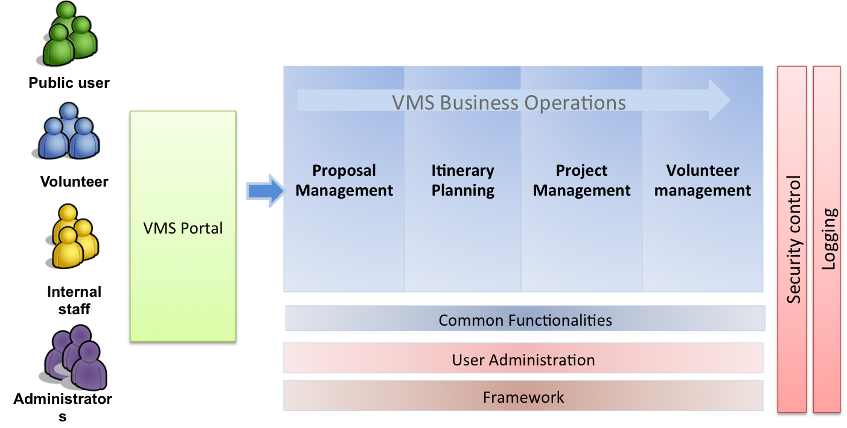

Figure 1 – Application Architecture Diagram

Hardware Architecture
The following depicts the hardware architecture design of the system:
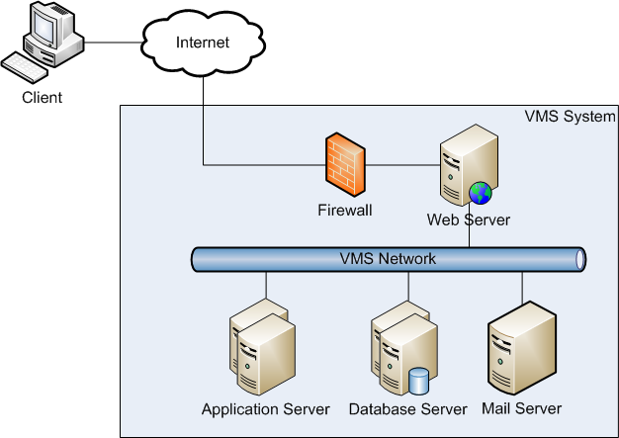

Figure 2 – Hardware Architecture

Software & Hardware Platform
The actual application and development will be running on the Windows platform.

Technologies & Tools
The following diagram depicts the technologies and tools used for this system.
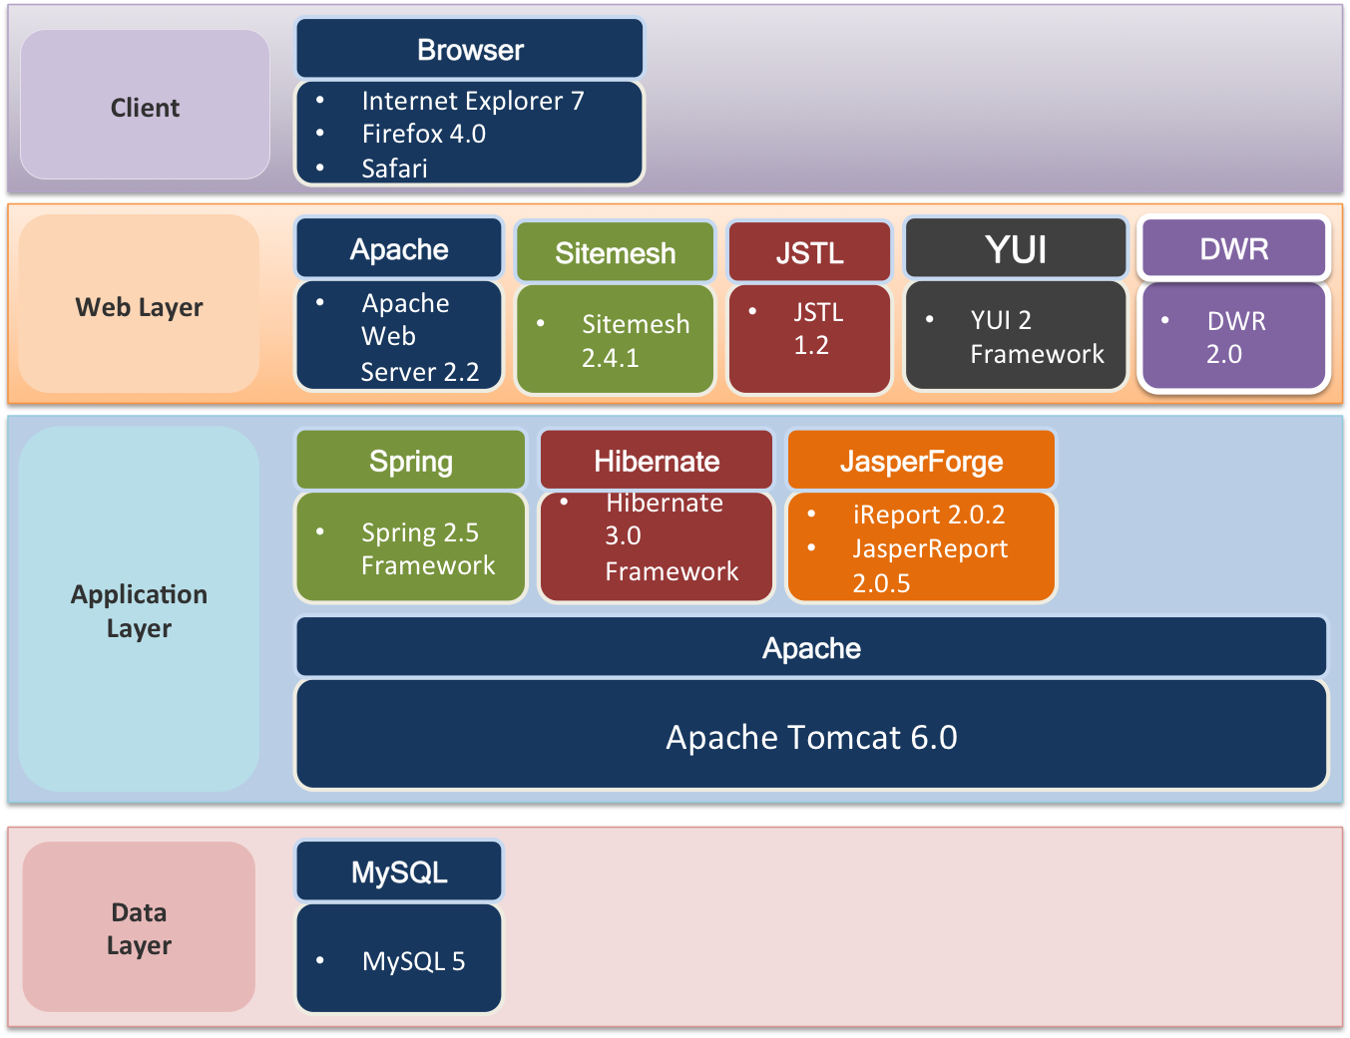

Figure 3 – Overview of Technologies & Tools

Client
The system will support the Internet Explorer 7 and Firefox 4.

Web Layer
The front end web tier layer will be handling the .

Middle Tier
The following depicts the requirements functionalities that reside in the system.

Data Layer
The following depicts the requirements functionalities that reside in the system.

Project Development Structure

Design of Modules
This section discuss about the segregation of modules. Defining the frontend, backend and helper classes.

Development Tools Configuration
This section defines the configuration required for the development tools that are used for the system. Such as how eclipse is configured, etc.

Development Environment
This section defines the development environment, such as how many dbs?.

User Interface Design Guidelines

Naming Convention

View Resolvers()

MessageProperty
This section discuss about the naming convention of the UI components used for the jsp pages.

JSTL

The JSP Standard Tag Library (JSTL) is a collection of JSP 1.2 custom tag libraries that implement basic functionality common to a wide range of server-side Java applications. By providing standard implementations for typical presentation-layer tasks such as data formatting and iterative or conditional content, JSTL allows JSP authors to focus on application-specific development needs, rather than "reinventing the wheel" for these generic operations.

The following JSTL libraries will be used to simplify JSP development
Library | URI | Prefix
Core  Bean access, flow control, collection handling, URL management | http://java.sun.com/jsp/jstl/core | c
Formatting  I18N formatting for messages, numbers and dates | http://java.sun.com/jsp/jstl/fmt | fmt
Functions  String manipulation | http://java.sun.com/jsp/jstl/functions | fn

JSTL Core Library

Displaying Value

Conditional Action

Iterator Action

URL Related Action

Formatting Library

Formatting Numbers, Currencies, and Percentages

Formatting Dates and Times

Function Tag library

Change the capitalization of a string (toLowerCase, toUpperCase)

Get a subset of a string (substring, substringAfter, substringBefore)

Trim a string (trim)

Replace characters in a string (replace)

Check if a string contains another string (indexOf, startsWith, endsWith,

contains, containsIgnoreCase)

split a string (split) into an array, and join an array into a string (join)

Escape XML characters in the string (escapeXml)

Dynamic Interactions

Request-Response Flow

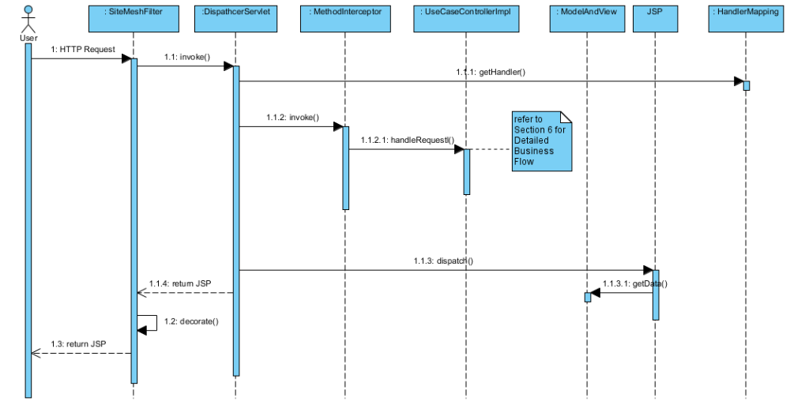

AOP Authentication

Authentication Flow

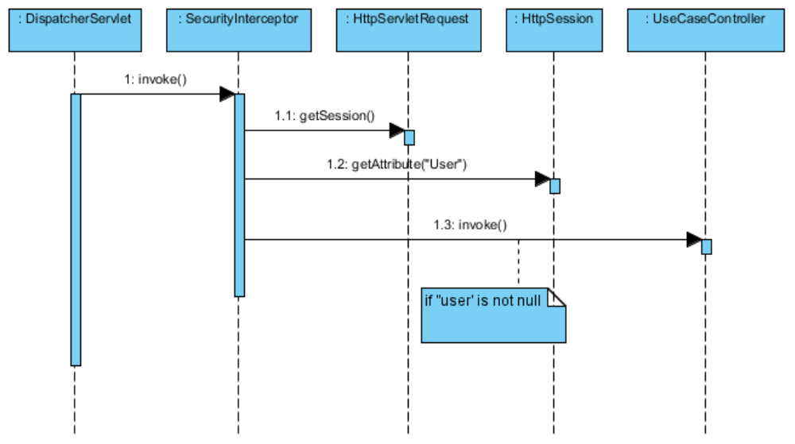

Main Flow

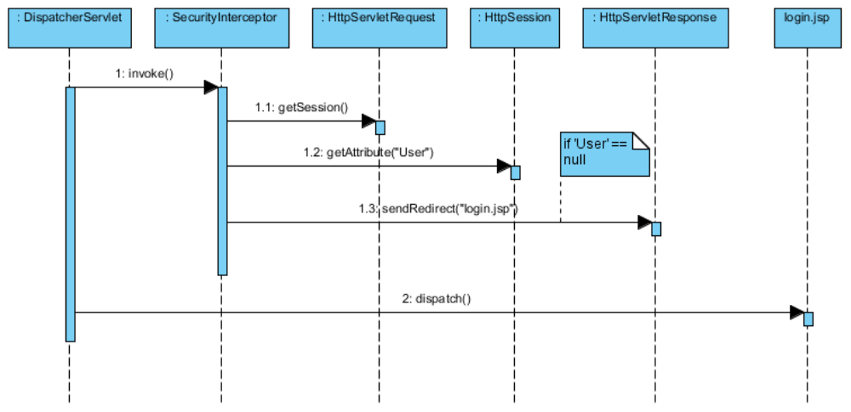

Exceptional Flow

Form Validation

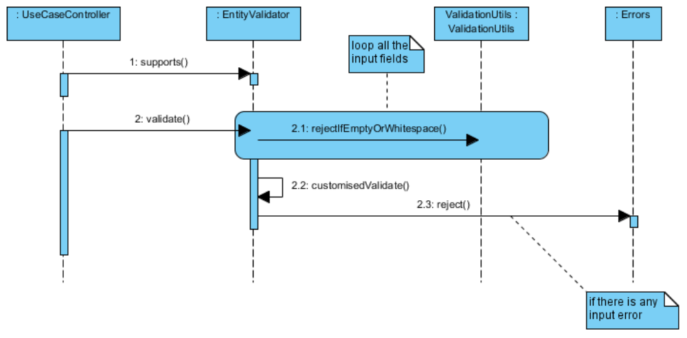

Configuration

a) add the form:errors tags in the jsp page to display the errors.

Sample Configuration:
<form:form method="POST" commandname="user">
<table>
<tr>
<td>User Name :</td>
<td><form:input path="name" /></td>
<td><form:errors path="name" cssClass="error" /></td>
</tr>
<tr>
<td>Password :</td>
<td><form:password path="password" /></td>
<td><form:errors path="password" cssClass="error" /></td>
</tr>
</table>
</form:form>

b) In the Spring configuration file, link the Validator with the Controller using the validator-ref property and add the properties file.

Sample Configuration:
<bean id="userValidator" class=" sg.edu.nus.iss.vms.web.validator.UserValidator" />
<bean name="/userRegistration.htm" class=" sg.edu.nus.iss.vms.web.controller.UserController" p:userService-ref="userService" p:formView="userForm" p:successView="userSuccess" p:validator-ref="userValidator" />

This section include jsp, custom tags, authentication, authorisation, how you want to code your jsp? How to name jsp, header, footer.

Middle Tier (Spring)

Static Structure
The following class diagram illustrates the static structure of the design.
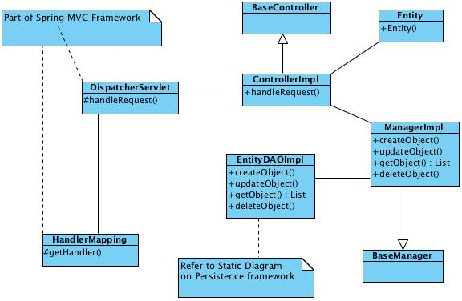

Figure 4 – Static Structure

Dynamic Interactions
The following sets of dynamic interactions are supported for each accessor function of creation, retrieval, update and deletion.

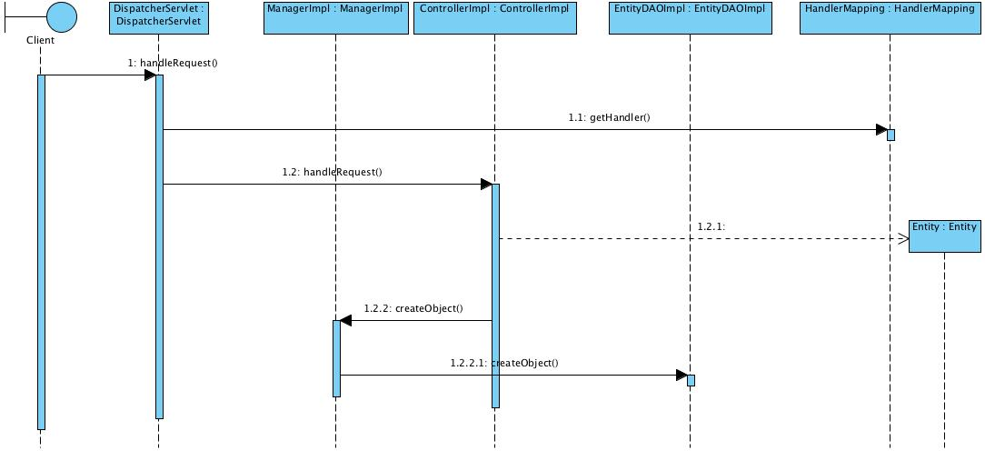

Figure 5 – Creation
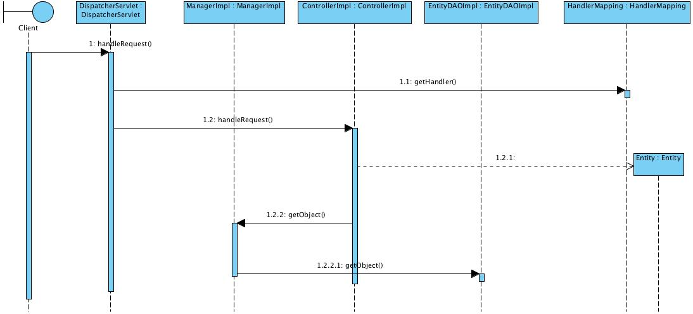

Figure 6 – Retrieval

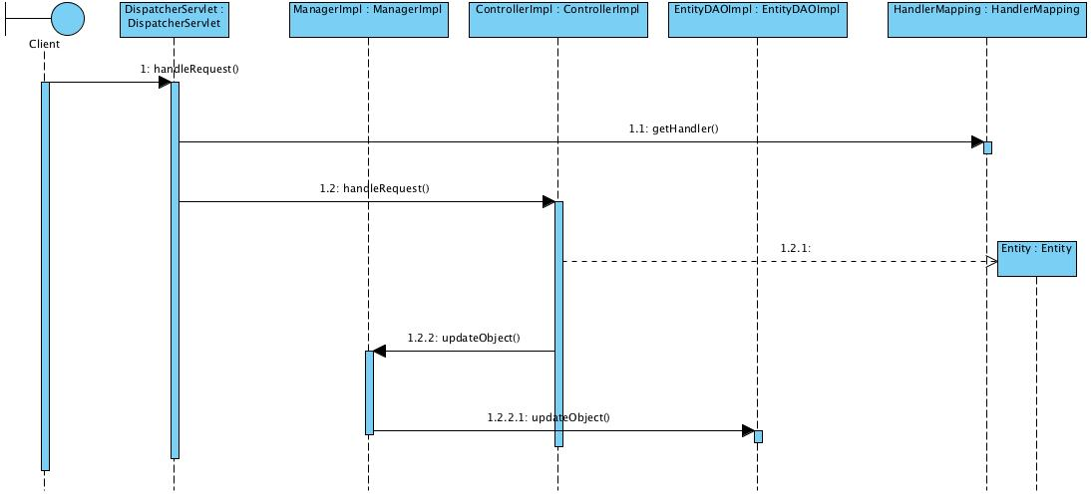

Figure 7 – Update

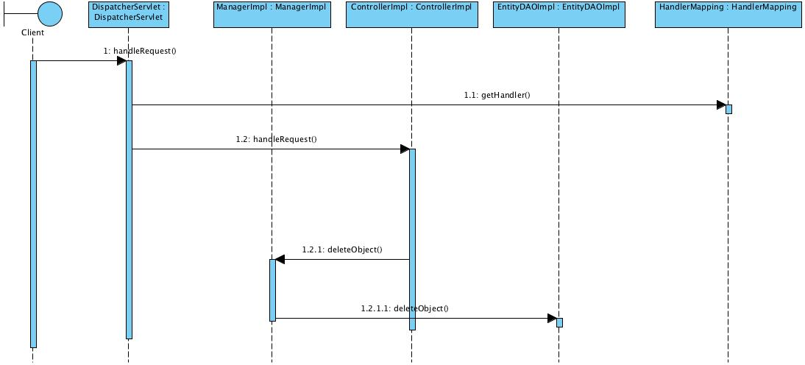

Figure 8 – Deletion

Configuration
This section contains the Spring configuration to be used.
- spring-controller-vms.xml to configure all the business logic beans/ page beans and dwr beans
- spring-hibernate-vms.xml to configure hibernate session factory
- spring-security.xml to configure the spring security interceptor

SMTP Utility
This section defines the development environment.

Static Structure
The following class diagram illustrates the static structure of the design.
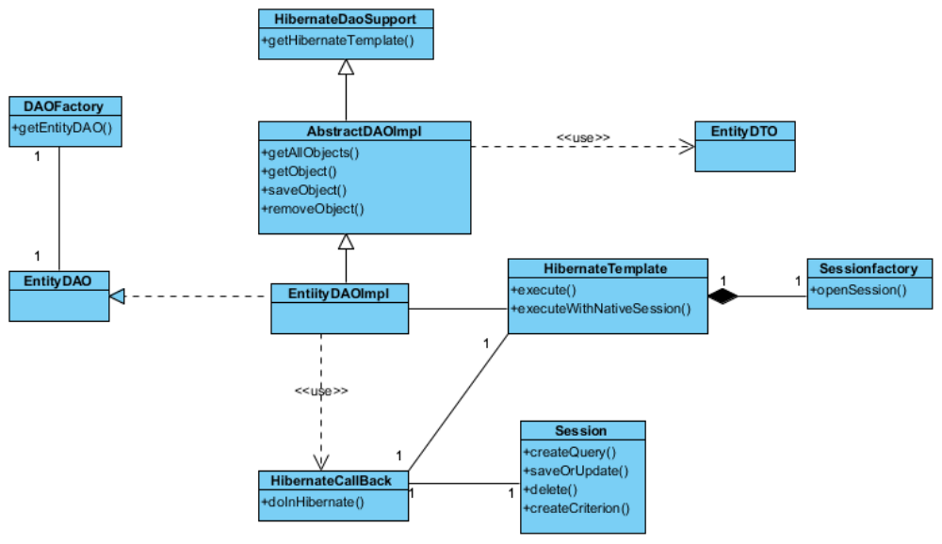

Figure 9 – Static Structure

Dynamic Interactions
The following sets of dynamic interactions are supported for each persistent entity object.
- Instantiation of a DAO
- Traversal of all the DTOs (including retrieval of the values of the attributes of the DTOs)
- Addition and Modification of a DTO
- Removal of a DTO

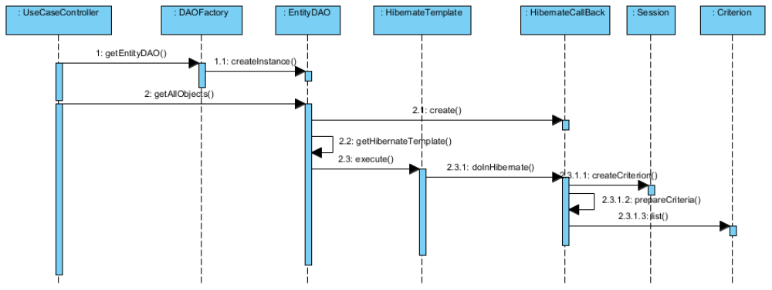

Figure 10 – Instantiation of DAO

Configuration
Email configuration file (cfg-mail.properties) is to set email user that vms will be use to send email alert as follow.

sys.server.mail.send.host=vms.com.sg
sys.server.mail.send.username=volunteers
sys.server.mail.send.password=user123
sys.server.mail.send.port=25

sys.server.mail.receive.host=vms.com.sg
sys.server.mail.receive.username= volunteers
sys.server.mail.receive.password=user123
sys.server.mail.receive.port=110

Persistence
The persistence for the VMS system is built based on Hibernate. Hibernate enables Application to access data from any database in a platform-independent manner. There is no need for the Application to depend on the low-level JDBC details like managing connection, dealing with statements and result sets. All the necessary details for accessing a particular data source is easily configurable in Xml files.
One of the issue with using Hibernate is that the client Application that accesses the database using Hibernate Framework has to depend on the Hibernate APIs like Configuration, SessionFactory and Session. These objects will continue to get scattered across the code throughout the Application. Moreover, the Application code has to manually maintain and manage these objects. In the case of Spring, the business objects can be highly configurable with the help of IOC Container. In simple words, the state of an object can be externalized from the Application code. It means that now it is possible to use the Hibernate objects as Spring Beans and they can enjoy all the facilities that Spring provides.
The details of DAO method design would be left to the programmer.

Static Structure
The following class diagram illustrates the static structure of the design.

Figure 11 – Static Structure

Dynamic Interactions
The following sets of dynamic interactions are supported for each persistent entity object.
- Instantiation of a DAO
- Traversal of all the DTOs (including retrieval of the values of the attributes of the DTOs)
- Addition and Modification of a DTO
- Removal of a DTO
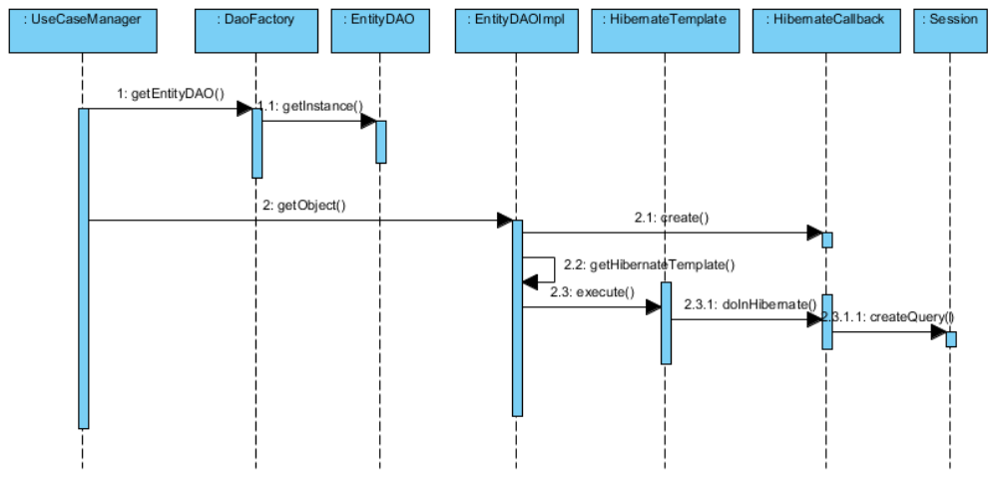

Figure 12 – Instantiation of DAO
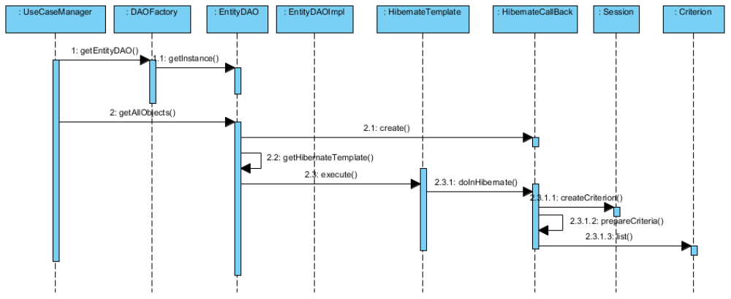

Figure 13 – Instantiation of DAO

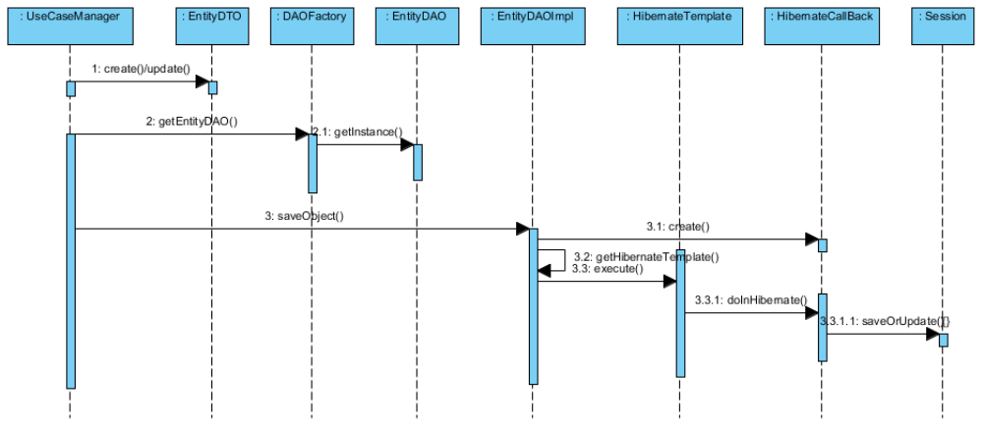

Figure 14 – Addition/Modification of DTO

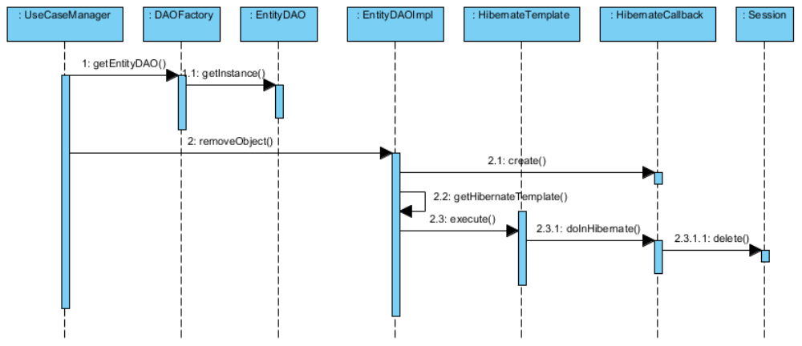

Figure 15 – Deletion of DTO

Configuration
This section deals with configuring the various information needed for the Spring Framework. In Spring, all the business objects are configured in Xml file as Spring Beans. These Spring Beans are maintained by the IOC which is given to the Client Application upon request. The hibernate-Spring bean mapping is defined as follows:
<beans>
<!-- Hibernate SessionFactory -->
<bean id="sessionFactory class="org.springframework.orm.hibernate3.annotation.AnnotationSessionFactoryBean">
<property name="dataSource" ref="dataSource" />
<property name="packagesToScan">
<list>
<value>sg.edu.nus.iss.vms.staffmgmt.dto</value>
</list>
</property>
<property name="hibernateProperties">
<props>
<prop key="hibernate.dialect">org.hibernate.dialect.MySQLDialect</prop>
<prop key="show_sql">true</prop>
</props>
</property>
</bean>

<bean id="hibernateTemplate" class="org.springframework.orm.hibernate3.HibernateTemplate">
<property name="sessionFactory" ref="sessionFactory" />
</bean>
</beans>

Table 2 – Hibernate XML Configuration
Since the annotations will be used instead of hibernate mapping files, the first bean defines type 'org.springframework.orm.hibernate3.annotation.AnnotationSessionFactoryBean’. AnnotationSessionFactoryBean.
The 2rd important Spring Bean is the Hibernate Template. It provides a wrapper for low-level data accessing and manipulation. Precisely, it contains methods for inserting/deleting/updating/finding data in the database. For the Hibernate Template to get configured, the only argument is the SessionFactory object as represented in the following section.

Naming Convention
This section defines the naming convention for the xml files and maps used for Hibernate.
Blah blah blah..

Standards
One module will contain one DAO object, unless it is a complex or many functions are residing within one module, and then multiple DAO objects will be created. The complexity level of a module will be left to the designer to decide.

Reporting Utility

Static Structure
The following class diagram illustrates the static structure of the design.
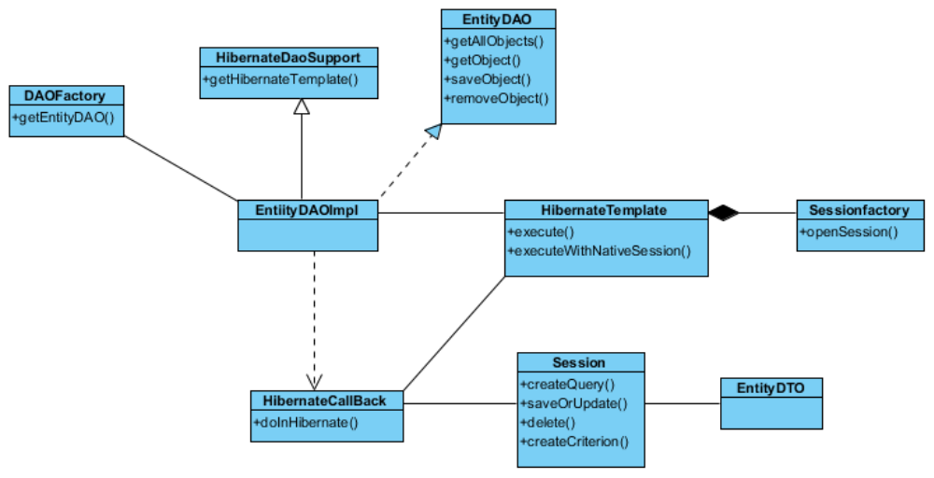

Figure 16 – Static Structure

Dynamic Interactions
The following sets of dynamic interactions are supported for each persistent entity object.
- Instantiation of a DAO
- Traversal of all the DTOs (including retrieval of the values of the attributes of the DTOs)
- Addition and Modification of a DTO
- Removal of a DTO

Figure 17 – Instantiation of DAO

Others

J2EE Packaging
This section discuss about the segregation of modules. Defining the frontend, backend and helper classes.

Build Configuration
Will be using Ant 1.6.5 to compile, packaging and deploy. Ant will be used for all the deployment environments from development to production.

Other Configurations
This section discuss about all other configurations used for the system.

Database Configuration
cfg-database.properties is to configure the database connection parameters such as JNDI, number of cached statements, timeout of pool connection and validation SQL. The logger will save the information into the file and file will be splitted into different file based on the file format
(“vms .log.2011-03-25.log”).

Logger Configuration
log4j.properties file can be found under the src folder. The application log flag, log level and log location configuration can be configured.
# Direct log messages to stdout
log4j.appender.stdout=org.apache.log4j.ConsoleAppender
log4j.appender.stdout.Target=System.out
log4j.appender.stdout.layout=org.apache.log4j.PatternLayout
log4j.appender.stdout.layout.ConversionPattern=[VMS] %d [%-5p] [%t] %c.%M(%-L) | %m%n

# Root logger option
#log4j.rootLogger=INFO, stdout
log4j.logger.org.springframework=ERROR
#log4j.rootCategory=error, stdout, R
log4j.rootCategory=DEBUG, stdout, R
log4j.appender.R=org.apache.log4j.RollingFileAppender
log4j.appender.R.File=logs/vms.log
log4j.appender.R.MaxFileSize=10000KB

#detail log filter
log4j.logger.mtech.se1008s.service.DispatcherServlet=ERROR

Java Naming Convention
This section defines the naming conventions that will be used for the design and implementation.

Package
All packages shall be prefixed with: sg.edu.nus.iss.vms. Further subdivision is up to the individual programmer. In the case of common code, reusable components shall be placed within a package named according to the component, such as sg.edu.nus.iss.vms.common.

Class and Interface
- Class names shall be nouns, not verbs. Eg. Staff, Project
- Interface names shall be an adjective (wherever possible) describing the enforced behaviours of the class. Preferably, interface names end in "able" following an emerging preference in Java. i.e. Clonable, Versionable, Taggable, etc.
- Class, and interface names shall begin with an uppercase letter, and shall not be pluralized unless it is a collection class.

Method
Method names are typically verbs. However they can also include nouns for example accessor methods (getter and setter). The following table describes the naming convention for method.
Accessor Type | Naming Convention | Example
Create | createXXX | createProject
Retrieve | getXXX | getProject
Update | updateXXX | updateProject
Delete | deleteXXX | deleteProject

Table 3 – Method
If the method is an accessor method, use a noun appropriate to the information that is returned, i.e.
public Project getProject()
public void setProject(Project project)

When accessing a collection class or an array, it is recommended to use pluralized noun for clarification, i.e:

public ArrayList<Event> getEventList()
public void setEventList(ArrayList<Event> )
public Project[] getProjects()
public void setProjects(Project[])

Attribute and Local Variable
Variable names shall follow the camel case convention. They shall begin with a lowercase letter. The initial letter of any subsequent words in the name is capitalized, and underscores are not used to separate words (or scope variables). Attributes that are not collections should not be pluralized. Eg. approvalName

Class & UI Naming Convention
Class Type | Naming Convention | Example
Boundary – Page | createXXX | createProject  createEvent
 | viewXXX | viewProjectList  viewCalendar
 | updateXXX | updateProject
 | deleteXXX | deleteProject
Boundary – Elements | xxxButton | createButton  deleteButton
 | xxxLabel | xxxLabel
Control | XXXController | MainController, ProjectController
Manager | XXXManager | ProjectManager
Service Implementation | XXXManagerImpl | ProjectManagerImpl
Data Access | XXXDAO | ProjectDAO
Entity | XXX | Project, Staff
Constants | XXX_YYYY | MINIMUM_WAGE

Table 4 – Class & UI Naming Convention Method

Documentation
The implementation code shall contain detailed documentation for classes, methods, and variables, written in Javadoc style as required by the Java coding standards. The overall guidelines to generate Javadoc include:
- Document all classes and methods
- Internal details need not be documented
- Methods that implement an interface need not provide javadoc comments, since the javadoc comments are included in the interface and will be referenced when javadoc executes.
- Each method shall include the @exception, @param, and @return javadoc tags where appropriate. Eg.

Acceptable
/**
* Method to check if proscribed operation is allowed for this object.
* This method is needed to provided some level of security on operations.
*
* @param action must be an operation that has registered itself with the object
* @return boolean true if the operation is allowed, false otherwise.
* @exception UnknownException exception is thrown when an operation that has not
* registered with the object is passed as a parameter.
*
*/
public boolean operationIsAllowed(Operation action) throws UnknownException
{
}

Table 5 – Acceptable Javadoc Syntax

Unacceptable (no Javadoc tag)
/**
* operation check takes an operation and returns true or false
*/
public boolean operationIsAllowed(Operation action) throws UnknownException
{
}

Table 6 – Acceptable Javadoc Syntax

Method names are typically verbs. However they can also include nouns for example accessor methods (getter and setter). The following table describes the naming convention for method.

      - Acceptable

      - Unacceptable (no Javadoc tag)

ANNEX D Amendment History

This is a record of all amendments made to the Document.
Version | Chapter / Section | Page No | Notes of Amendments or Changes

